Tutorial 3

- Using the following INVOICE table structure, draw its dependency diagram and identify all dependencies (including all partial and transitive dependencies). You can assume that the table does not contain repeating groups and that any invoice number may reference more than one product. (Hint: This table uses a composite primary key.)

Inv_num | Prod_num | Sale_date | Prod_label | Vend_code | Vend_name | Quant_sold | Prod_price
211347 | AA-E3422QW | 15-Jan-2004 | Rotary sander | 211 | NeverFail, Inc. | 1 | $49.95
211347 | QD-300932X | 15-Jan-2004 | 0.25-in. drill bit | 211 | NeverFail, Inc. | 8 | $3.45
211347 | RU-995748G | 15-Jan-2004 | Band saw | 309 | BeGood, Inc. | 1 | $39.99
211348 | AA-E3422QW | 15-Jan-2004 | Rotary sander | 211 | NeverFail, Inc. | 2 | $49.95
211349 | GH-778345P | 16-Jan-2004 | Power drill | 157 | ToughGo, Inc. | 1 | $87.75
Figure 1 INVOICE

- Consider the following relation definition and sample data:

PROJECT relation

ProjectID | EmployeeName | EmployeeSalary
100A | Jones | 64K
100A | Smith | 51K
100B | Smith | 51K
200A | Jones | 64K
200B | Jones | 64K
200C | Parks | 28K
200C | Smith | 51K
200D | Parks | 28K

PROJECT(ProjectID, EmployeeName, EmployeeSalary)
Where ProjectID is the name of a work project
EmployeeName is the name of an employee who works on that project
EmployeeSalary is the salary of the employee whose name is EmployeeName

Assuming that all of the functional dependencies and constraints are apparent in this data, which of the following statements is true?
- ProjectID -> EmployeeName - False

- ProjectID -> EmployeeSalary - False

- (ProjectID, EmployeeName) -> EmployeeSalary

- EmployeeName -> EmployeeSalary

- EmployeeSalary -> ProjectID

- EmployeeSalary -> (ProjectID, EmployeeName)

- What is the key of PROJECT?

- Are all non-key attributes (if any) dependent on the entire key?

- In what normal form is PROJECT?

- Describe two modification anomalies from which PROJECT suffers.

- Is ProjectID a determinant?

- Is EmployeeName a determinant?

- Is (ProjectID, EmployeeName) a determinant?

- Is EmployeeSalary a determinant?

- Redesign this relation to eliminate the modification anomalies.

- Figure 2 below shows a shipping market. Answer the questions that follow by referring to the figure.
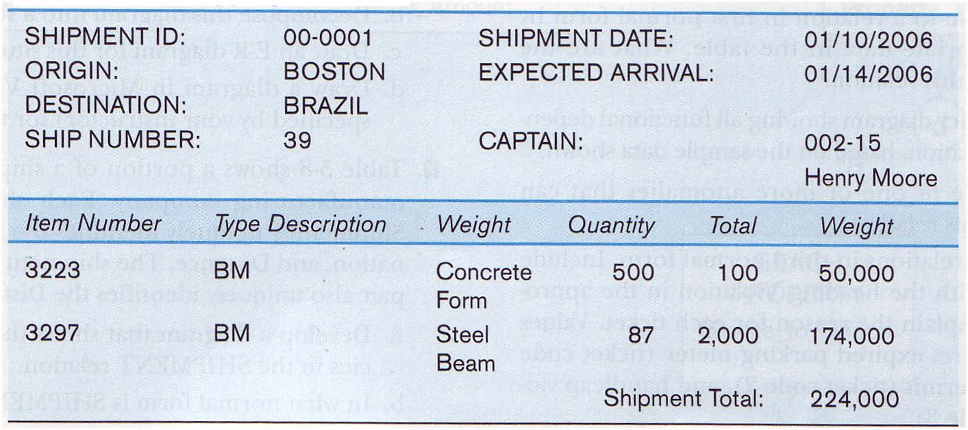

Figure 2 Shipping Manifest

(a) Draw a functional dependency diagram for the given relation.

- In what normal form is this relation?

- Decompose the relational schema into a set of 3NF relations.
.

- Examine the Patient Medication Form for the Wellmeadows Hospital case study shown in Figure 3.

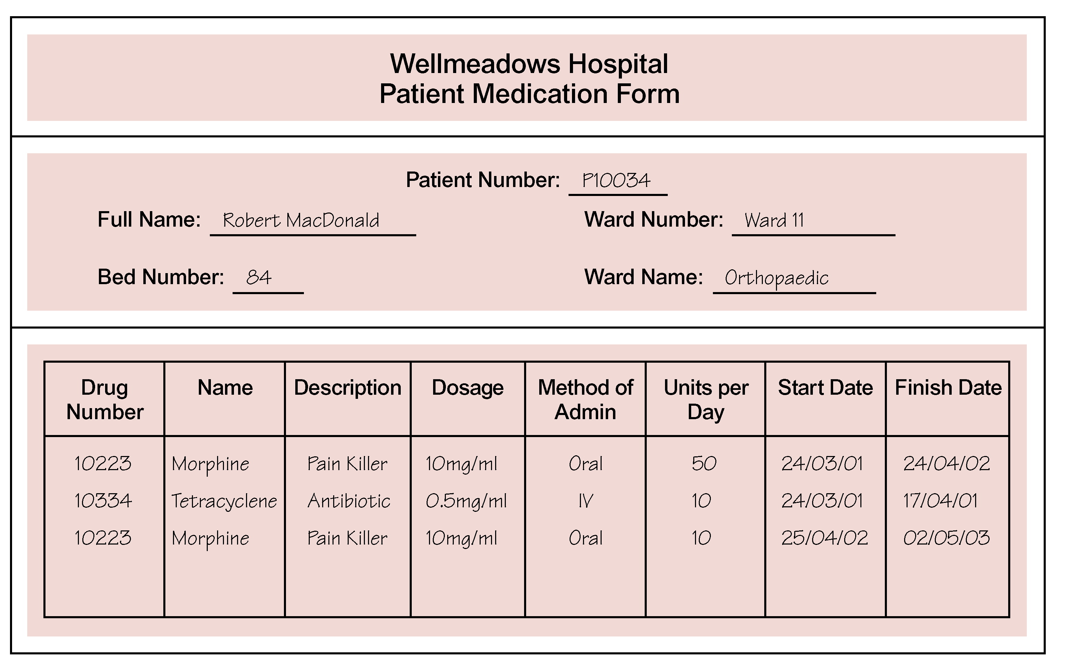

Figure 3 The WellMeadows Hospital Patient Medication Form.

(a) Identify the functional dependencies represented by the data shown in the form in Figure 3.

(b) Describe and illustrate the process of normalizing the data shown in Figure 3 to first (1NF), second (2NF), third (3NF), and BCNF.

- Identify the primary, alternate, and foreign keys in your BCNF relations.

- An example table from the University Database might be as follows.

S_Num | T_Code | Offering# | Review Date
123599 | FIT104 | 01764 | 2nd March
123599 | PIT305 | 01765 | 12th April
123599 | PIT107 | 01789 | 2nd May
346700 | FIT104 | 01764 | 3rd March
346700 | PIT305 | 01765 | 7th May

Normalize the above table to BCNF.

- Normalize following table to 4NF.

